**DAILY ONLINE ACTIVITIES SUMMARY**

|  |  |  |  |  |  |  |  |  |
| --- | --- | --- | --- | --- | --- | --- | --- | --- |
| **Date:** | **09/07/2020** | | | | | **Name:** | **Lavanya D M** | |
| **Sem & Sec** | **4th & ‘A’** | | | | | **USN:** | **4al18cs041** | |
| **Online Test Summary** | | | | | | | | |
| **Subject** | | **----** | | | | | | |
| **Max. Marks** | | **----** | | **Score** | | | **-----** | |
| **Certification Course Summary** | | | | | | | | |
| **Course** | Introduction to Block chain | | | | | | | |
| **Certificate Provider** | | | **Bitdegree** | | **Duration** | | | **4days** |
| **Coding Challenges** | | | | | | | | |
| **Problem Statement:** 1) C++ program to find Unique Number using Bit Masking**.** 2) Find next and previous power of two of a given number in C++ | | | | | | | | |
| **Status: Complied** | | | | | | | | |
| **Uploaded the report in Github** | | | | | **yes** | | | |
| **If yes Repository name** | | | | | <https://github.com/lavanyamurthi/lockdown-coding> | | | |
| **Uploaded the report in slack** | | | | | **yes** | | | |

Online Test Details: (Attach the snapshot and briefly write the report for the same)

No test conducted

Certification Course Details: (Attach the snapshot and briefly write the report for the same)

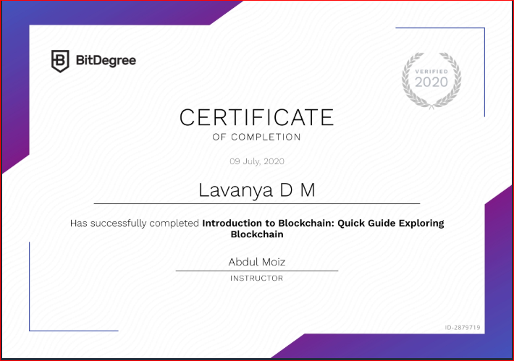

Coding Challenges Details: (Attach the snapshot and briefly write the report for the same)

# **Problem 1 :** C++ program to find Unique Number using Bit Masking

## 

|  |
| --- |
|  |
|  |  |

# **Problem 2:**Find next and previous power of two of a given number in C++

